Project Initialization and Planning Phase 
Define Problem Statements
Date | 21 September 2026
Team ID | MCA
Project Name | Strategic Employee Attrition Intelligence Dashboard
Maximum Marks | 3 Marks

Customer Problem Statement
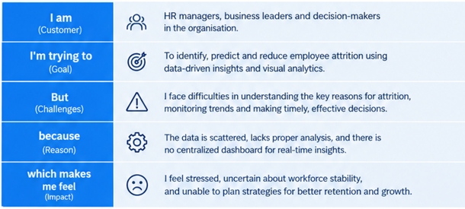
The uploaded employee dataset contains 5,000 employee records and 29 attributes. The analysis shows 895 employees marked as having attrition (17.9%). The project therefore focuses on helping HR and management understand where attrition is occurring and which workplace, compensation, career, wellbeing and AI-related factors are associated with it.
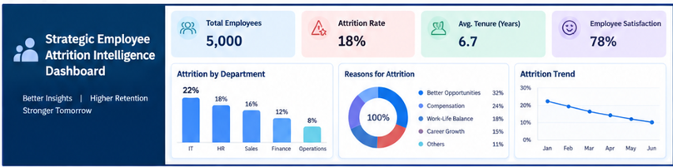
The statements below follow the supplied template structure: Customer → goal → barrier → reason → feeling.
Problem Statement (PS) | I am (Customer) | I’m trying to | But | Because | Which makes me feel
PS-1 | An HR manager or people-analytics decision maker | identify which employee groups and organizational areas have higher attrition and understand the main patterns behind employee exits | the information is spread across department, job role, work mode, compensation, tenure, workload, wellbeing and other employee attributes | a single employee-level dataset contains many variables that need to be compared and summarized before useful patterns can be seen | uncertain about where retention attention should be focused and how to communicate the findings clearly to management
PS-2 | A business manager responsible for employee retention | monitor employee attrition indicators and compare factors such as overtime, manager support, engagement, work-life balance and perceived AI job risk | it is difficult to quickly compare these factors with attrition using raw records or isolated reports | the current data requires filtering, aggregation and visual analysis to reveal meaningful differences between employees who stayed and employees who left | concerned that emerging retention risks may not be identified early enough

Project Focus Derived from the Problems
- Create an interactive Power BI dashboard that converts the 5,000-record employee dataset into understandable attrition insights.
- Show overall attrition, employee population and supporting KPI measures.
- Compare attrition across departments, work modes, job levels and other relevant employee dimensions.
- Explore workload and wellbeing indicators such as overtime, burnout, engagement, work-life balance and manager support.
- Include compensation, career-growth and AI-related indicators where they help explain observed attrition patterns.
- Enable management-oriented filtering and visual exploration rather than relying only on raw SQL outputs.

Data Quality Observation
The supplied CSV contains 5,000 rows and 29 columns. The initial completeness check found no missing values across the dataset. The attrition field contains 4,105 'No' records and 895 'Yes' records, corresponding to an overall attrition rate of 17.9%.

